Kory Damewood
Amber Lemiere
English 101
1-17-2014
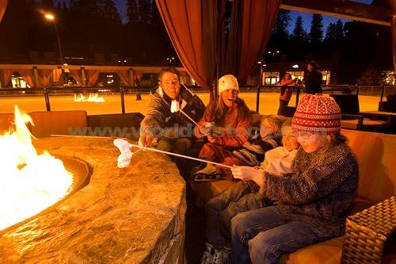
A Family Sitting Around A Fire Roasting Marshmallows By An Ice Skating Rink At Northstar Ski Resort Near Lake Tahoe In California. 2003-2013. Photograph. Vancouver, BC, Canada.
Weekend of Camping With Memories
How do you bond with a family? What are great family activities? Family is the most important thing in life, family is everything. Fire while camping is always a great thing to have. Some of my favorite memories with my family are just memories of playing games with them. Being out on the water with my family is something I always look forward to. Family is one of the most important things in my life; I love spending time with them, especially having the weekend up at the camp lot with them.
One of the best parts about going up to the camp lot is sitting around the fire. The fire is one of the most relaxing things to me and just sitting next to, I could do that all day long. I love reading books on kindle. I will just grab my iPad, go to kindle, start reading, and I would be a happy camper. Visiting with friends and family is also an amazing thing to do up at camp around the fire. We get to talk while relaxing and staying warm. We share stories and share laughs and make memories with each other that will stay with us forever. The warmth of a fire is like no other, it doesn't compare to other types of heat (like a heater in your house). As I grab my iPad and go to the fire, I pick a spot close enough but not to close. I recline my legs and open up the kindle app. Time to just relax and enjoy a nice peaceful atmosphere while reading a book. The sound of the fire crackling and seeing the flame in the corner of my eye is the best.
As the weekend goes on we as a family at camp play a lot of games together. That brings us really close together because we get to enjoy each other's company while playing games. One of the games we play up at camp is Ladder Ball which "is a lawn game played by throwing bolas (two balls connected by a string) onto a ladder" (Wikipedia). You want the ball to wrap around one of the three rungs that give you points and the first person to 21 wins. We decided to split up into teams playing Ladder Ball. My Brother and I versus my Dad and Uncle. As each person throws it's an intense few seconds waiting to see if the bola is going to wrap around that rung for points or not. As I'm ready to throw I concentrate on where that bola is going to go, I put all my focus onto it to make sure my Brother and I get some points for us; getting us one step closer to victory. It's a close match with my Brother and I with 19 points, and my Dad and Uncle with 20 points. I'm up to throw on my team and I missed my first two throws and I'm on my last one. One throw to either win or lose the game. I put all my thought into the bola, concentrating on this throw. My arm goes back and I release the bola. It feels like slow mo in my head but it only took a few seconds for that bola to wrap tightly around that second rung for two points. That won us the game! As the day comes to an end and the sun goes down, we set out a propane lamp and we play a card game called Pinochle. Some of just my favorite memories is playing pinochle with the family. We always laugh harder than we ever laugh on anything else. My uncle needed four aces to make his 1000 bid and it's hard enough doing that with 2 aces. When he told us he needed four aces, we just started laughing so hard where it hurt. That was such a low chance of getting four aces that he needed.
It isn't camping unless you're out on the water too and that's something we all love going out to do. The next day we all go out on the lake but the only problem with Lake Merwin is the cold water. Out on the water I'm ready to jump in to take a nice swim and when I jump, my body sinks in the water. Head goes down and I'm surrounded by freezing cold water all around me. Finally my head pops out of the top of the water and I take a painfully loud breath, recovering from the cold water. After a little while the body finally recovers from the cold water and starts adapting to the temperature. Next up on the to do list on the water is ride the Jet Skis. The wind in my face while riding is like no other, while I'm surrounded by water having the waves jump up and hit my entire body can be shockingly cold but also an amazing adventure. As I ride I always try and go and get some air from the waves made from other boats, (doesn't work to well). While riding I also try to do circles to throw some splash around, (works every now and then). Last on the to do list is to Wakeboard. It all starts by waiting for that boat to take off. Waiting in the water until I'm ready to be lifted out and up on the board. As that happens, that's where the rush comes in. Bumpy terrain and skimming on top of the water like I'm floating on top of the water. Only floating while getting waves of water hit on me and on an uneven surface. If I don't crash on accident then I eventually have to crash on purpose. The thought comes into mind to just let go but I start to think, "what if it hurts, what if something bad happens?" I let go of the rope and I keep riding on top of the water but eventually start sinking into the dark abyss. After just a quick few seconds I'm back into the cold freezing water with most of my body in it's grab.
Family time to me is one of the most important things in my life. Spending time around the fire with my family is one of the best things to do. Games with the family always make my stomach hurt from laughing so hard. Memories are always made being out on the water with my family. It's the small things in life that you do with your family that can bond you together.

